

**Bangabandhu Sheikh Mujibur Rahman Science and Technology University**

**Project Report on**

**Typing Game with c++**

|  |  |
| --- | --- |
| **Submitted By** | **Under the Guidance of** |
| **Israt Jahan Reshma**  **ID**-18CSE241  **Year:** 1st  **Semester:** 2nd  **Session:** 2018 – 19  Department Of CSE, BSMRSTU | **Abu Bakar Muhammad Abdullah** Assistant Professor,  Department Of Computer Science & Engineering.  BSMRSTU, Gopalgonj - 8100 |

**Course Code:** CSE178

**Date of Submission:** 7 September, 2023.

# **Abstract**

ABSTRACT

Typing Speed Calculator using Python is used to determine the typing speed of

its user. Typing Speed Calculator is an application for calculating the accuracy

and typing speed of its user. The system provides its user a specific paragraph

which must be typed by its user. The following presentation provides the

specification of the program

Typing speed Game using C-Graphics is used to determine the typing speed of its user. Typing speed game is an application for calculating the accuracy and typing speed of its user. The system provides its user a specific letter/word depend on which level is chose by user and which must be typed by its user. The following presentation provides the specification of program.

Typing is now essential part of almost every job imaginable. It helps to complete work faster and more efficiently, by comfortable with the computer, and help to communicate with co-workers and superiors. Trying to type something for long periods of time can cause fatigue and also restlessness, so it’s beautiful for health as well as to have good typing skills and gradually increase speed by practicing every day.

**Contents**

**Abstract** 2

**Introduction**: 4

**Objective:** 5

**Scope** 5

**Methodology** 5

**System Features** 6

**System Requirements:** 6

**Implementation Details:** 7

**Project’s goal:** 12

**References:** 12

Typing Speed Calculator as a project is based on relevant Technologies. The main aim of this project is

to develop a software which capable for a typing speed Calculator. This project has been developed

to carry out the process easily and effectively.

Typing Speed Calculator as a project is based on relevant Technologies. The main aim of this project is

to develop a software which capable for a typing speed Calculator. This project has been developed

to carry out the process easily and effectively.

Typing Speed Calculator as a project is based on relevant Technologies. The main aim of this project is

to develop a software which capable for a typing speed Calculator. This project has been developed

to carry out the process easily and effectively.

**Figures**

Figure 1. Home Page-1 7

Figure 2. Home Page-2 7

Figure 3. Main Menu 8

Figure 4. Roles Page 8

Figure 5. Last 10-Days Performance 9

Figure 6. Start Game 9

Figure 7.User Home Page 10

Figure 8. Typing Interface 10

Figure 9. Time Over 11

Figure 10. Exit 11

Figure 11. Close Window 12

# **Introduction:**

As personal computers appear on nearly every desktop in both service and manufacturing businesses, keyboarding skills have increasingly become a fundamental part of "computer literacy" In an earlier time, nearly all external and much internal business correspondence was prepared by a relatively few secretarial and clerical employees. In this era of local and wide area networks, however, most internal and much external correspondence is being typed on a computer keyboard in its final form by the person originating the message.

In a typical office setting, the person typing memos, technical reports, financial reports, etc. is very likely to be other than a clerical employee. In a production or factory setting, non-clerical factory workers and manual laborers are expected to input production data, industrial quality measurements, telephone orders, and other items of routine information into personal computers or keyboard terminals. As a result of this developing vocational picture, some level of keyboarding skill has rapidly become a baseline requirement for both professional and non-professional workers. This situation has translated into opportunities for increased employability, higher earnings, and further educational attainment for those with even basic keyboarding skills.

The huge financial investment associated with massive personal computer procurement for keyboarding classes invites an interesting question. If we assume that computer-based keyboard instruction methods are preferable for introducing students to computer literacy concepts, are they also a faster method of building keyboarding speed and accuracy?

The problem of this study was to determine the rate at which typing speed and accuracy were achieved using computer-based typing test application which is designed by c graphics.

# **Objective:**

The main objectives of the Typing Game Application are as follows:

a) Improving typing speed of user.

b) Improving typing accuracy of user.

c) Compare speed and accuracy with previous record.

# **Scope**

The scope of the project includes the following aspects:

**a) Data Collection:** The system will collect data from user performance.

**b) Data Processing:** The collected data will be processed and stored in a structured manner for further analysis.

**c) Data Analysis:** The system will perform various analytical operations on the collected data and calculate performance.

**d) Reporting:** The system will generate reports and visualizations to present the analyzed data in a user-friendly format.

**Methodology**

Typing Game follows a systematic approach for its development:

**a) Requirement Gathering:** Gather all of the requirements and understand the user's needs.

**b) System Design:** A detailed system design is prepared, including interface, data flow diagrams, and activity diagram.

**c) Development:** The system is designed using C-Graphics with Object Oriented programming and C++. File handling is also need.

**d) Testing:** The system undergoes rigorous testing to ensure its functionality, performance, and security.

**e) Deployment:** The system is deployed on a suitable infrastructure for live usage.

# **System Features**

The key features of the Typing Game Application include:

1. Test speed of user.
2. Calculate Accuracy
3. Compare with previous record

# **System Requirements:**

➢ C ++

➢ C graphics

➢ C File

➢ Object Oriented Programming with C++

Supported Operating System:

• Windows

• Linux

• Mac

# **Implementation Details:**

**Home Page**: We have to put a name to entire this application.

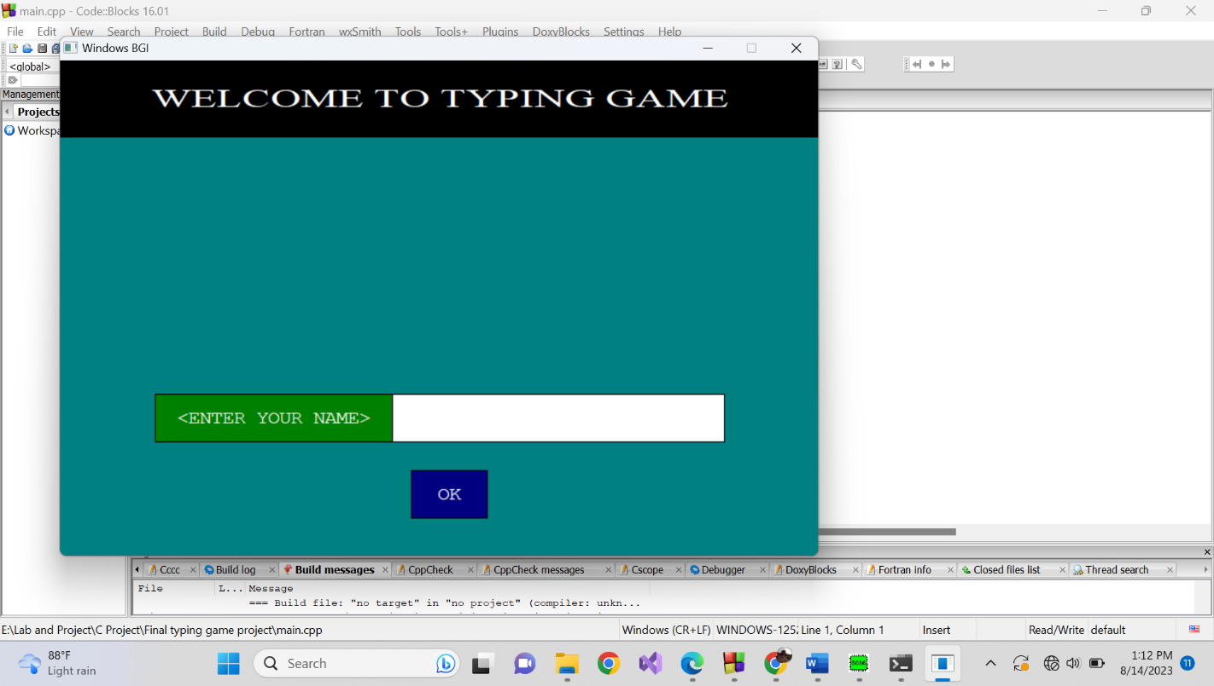

Figure 1. Home Page-1

Put a Name and press OK.

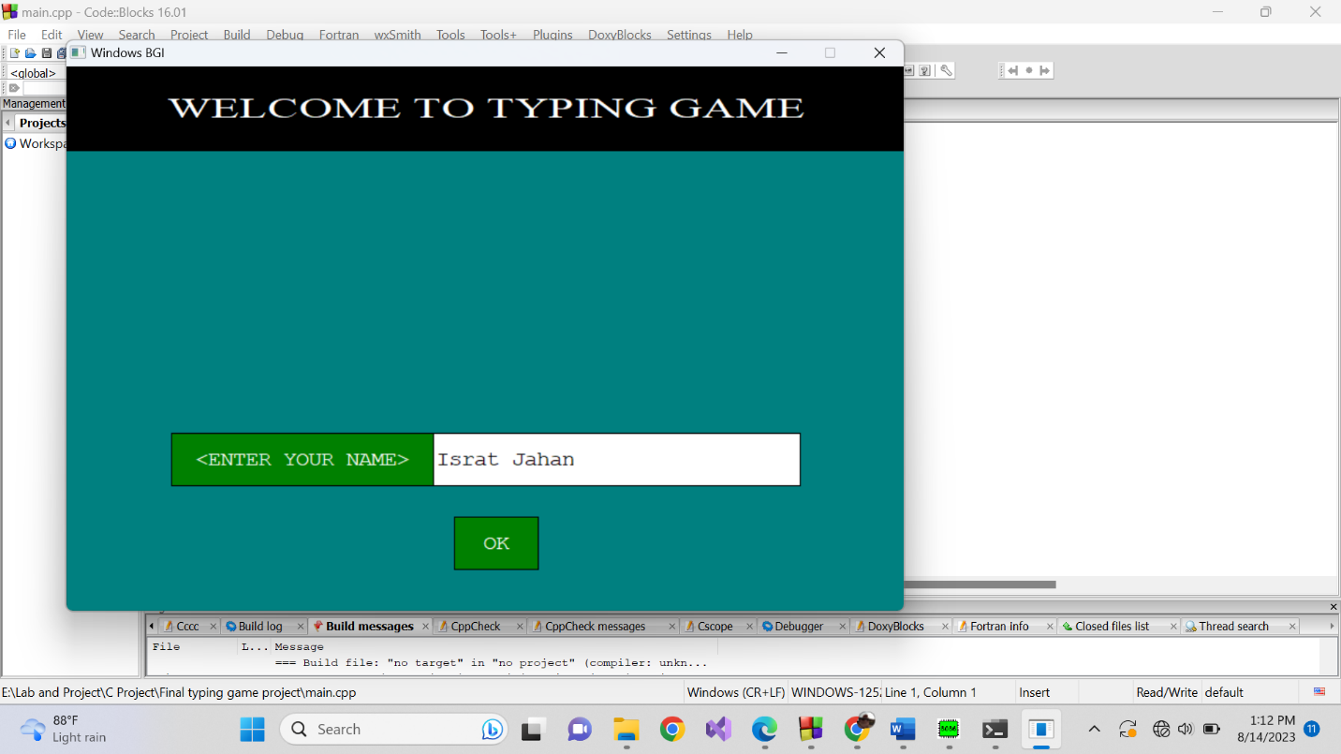

Figure 2. Home Page-2

**Main Menu:** Select any Button from main menu.

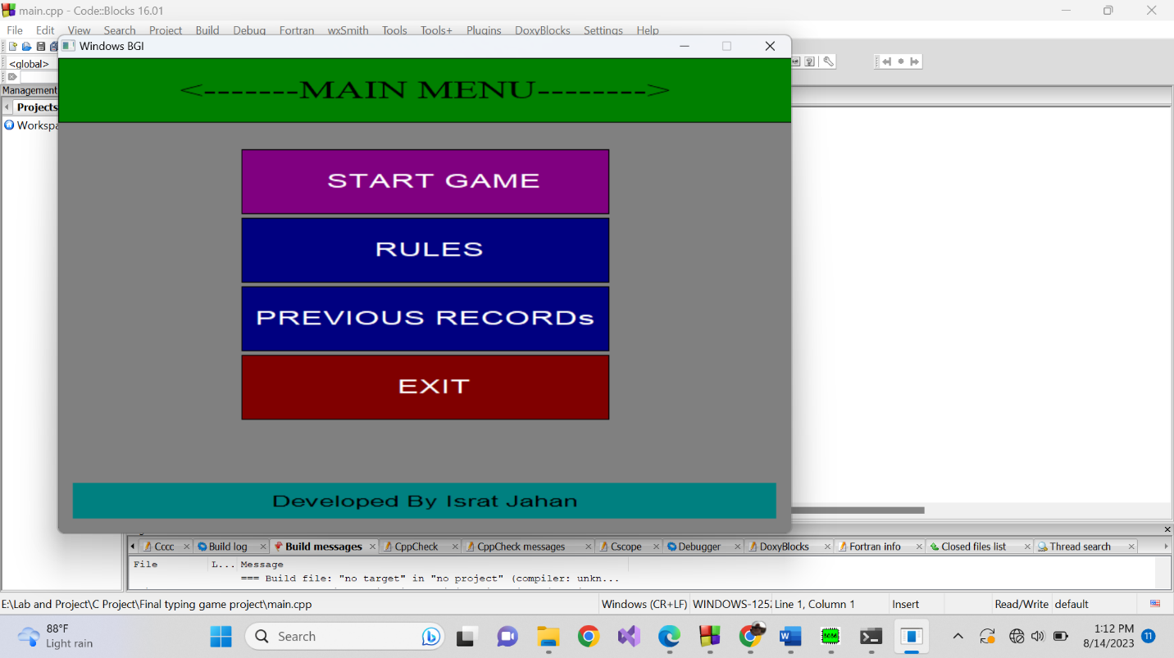

Figure 3. Main Menu

**Rules Page:** It’s better that know the rules before start the game.

The rules interface is below.

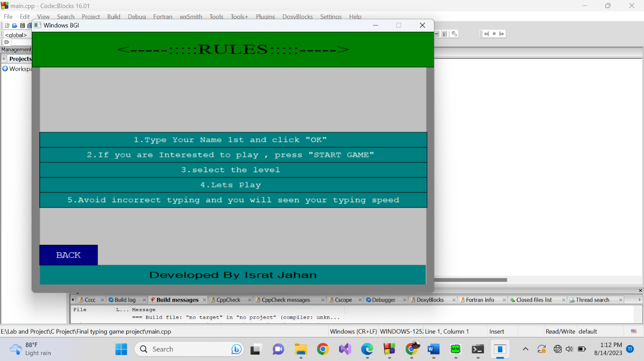

Figure 4. Roles Page

**Last 10-days performance:** You can see previous 10 days performance graph including accuracy and speed.

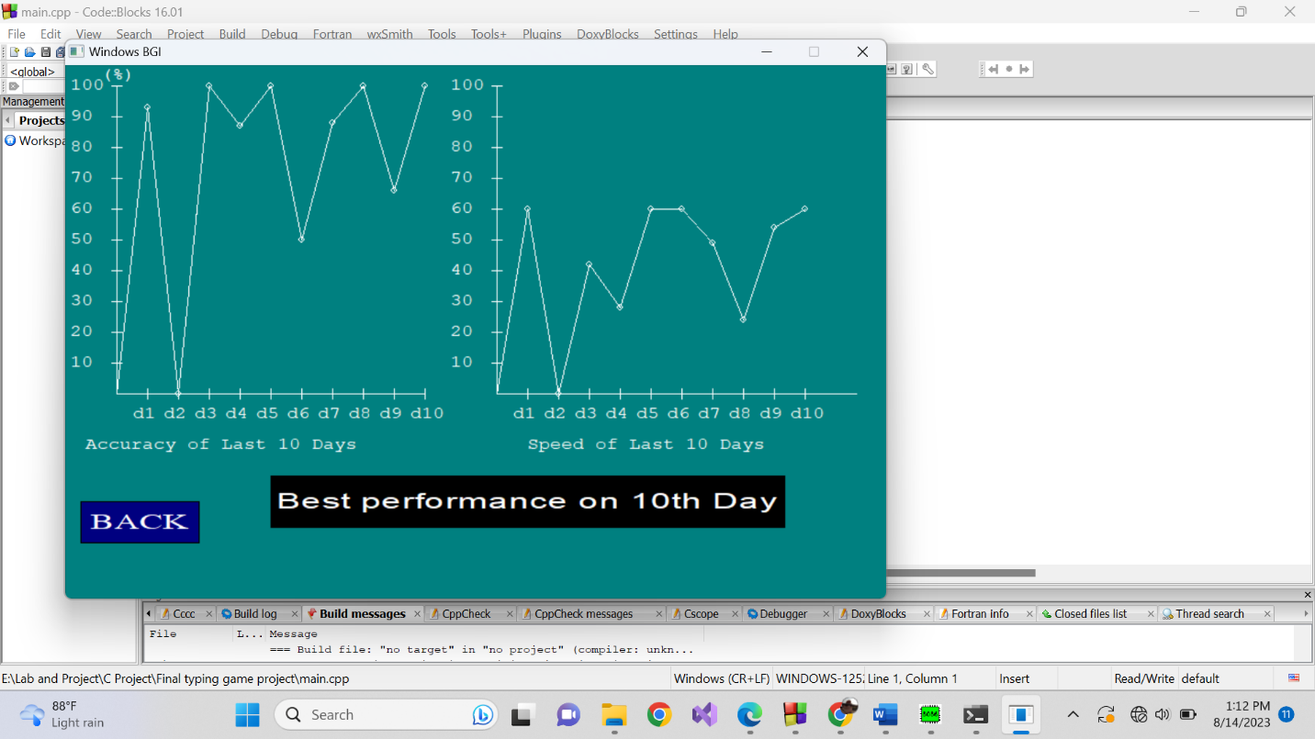

Figure 5. Last 10-Days Performance

**Start Game:** This is ‘Start Game’ interface.

This game has two labels named Easy and Hard. And each level is divided into 3 sub level. Sublevel is mainly named by covered time where sublevel-1 has 1 min, sublevel-2 has 2 min and sublevel-3 has 5 min for playing this game.

Easy: Hare letter is Typed

Hard: Hare Word is typed.

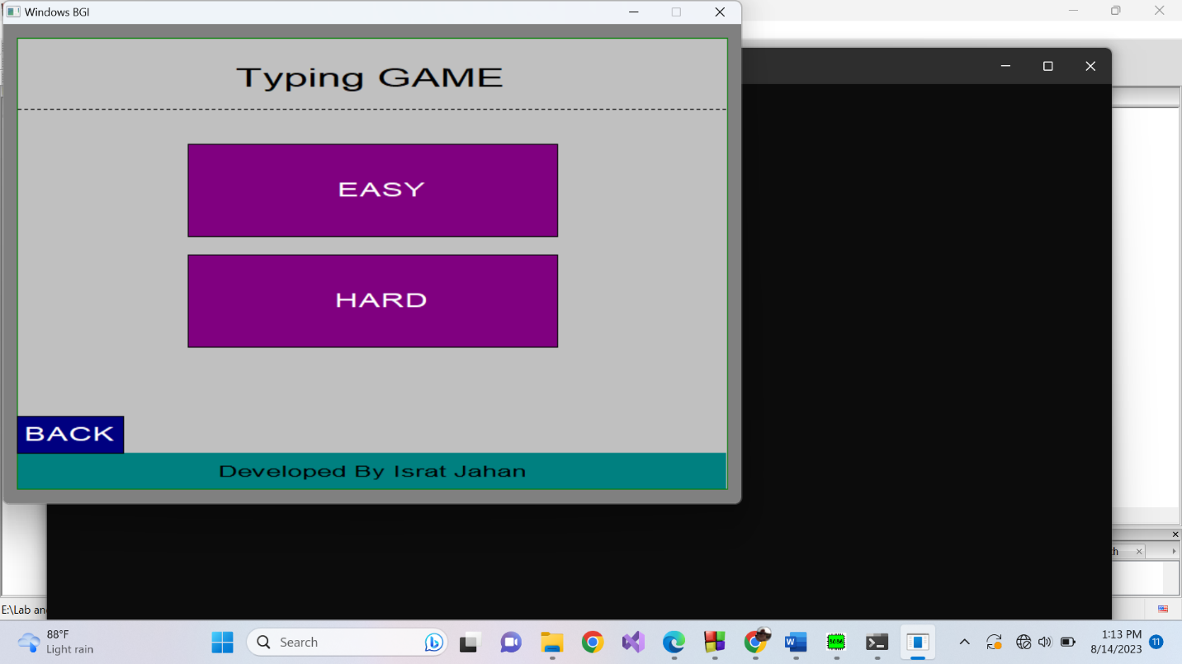

Figure 6. Start Game

**Easy Labels:**

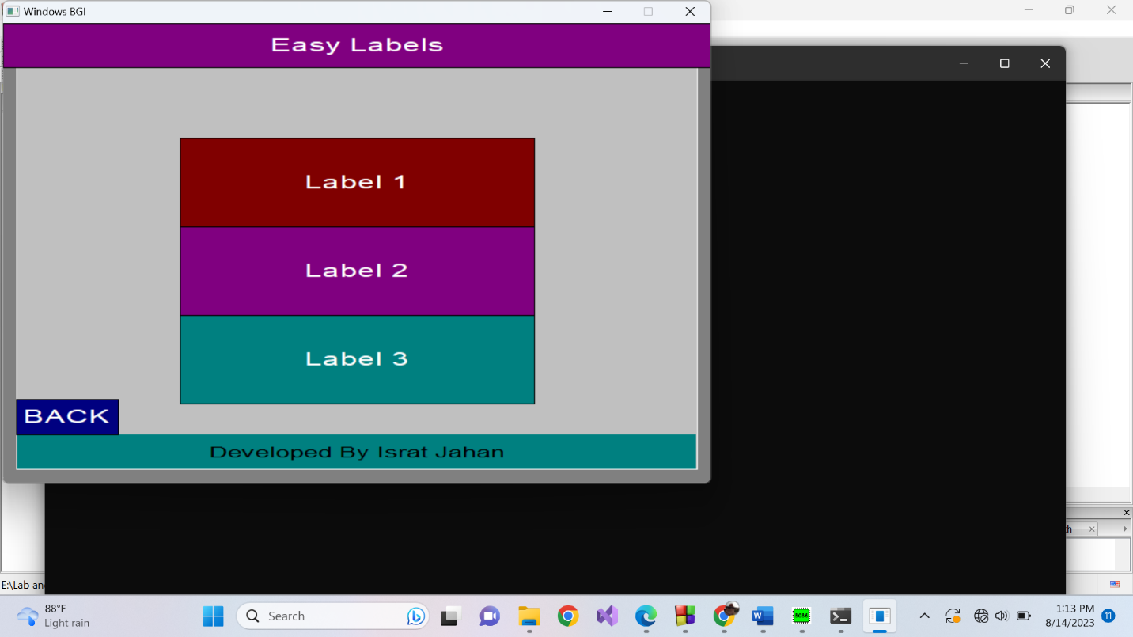

Figure 7.User Home Page

If user select level 2 then he/she get 2 min for test typing speed. A random letter/word is shown on screen and this is typed by user. By typed character/word, some parameter is calculated including correct or wrong character, Accuracy, speed as well as shown the remaining time also. Here user can restart or can go to next label and also can store the performance at any time which will be shown on previous records graph. Hare left image is from easy-label-2 and right image is from Hard-Label-3.

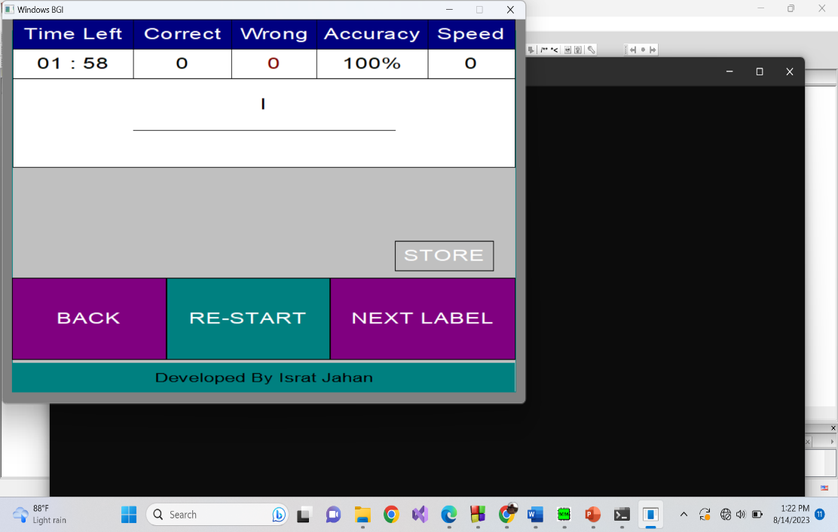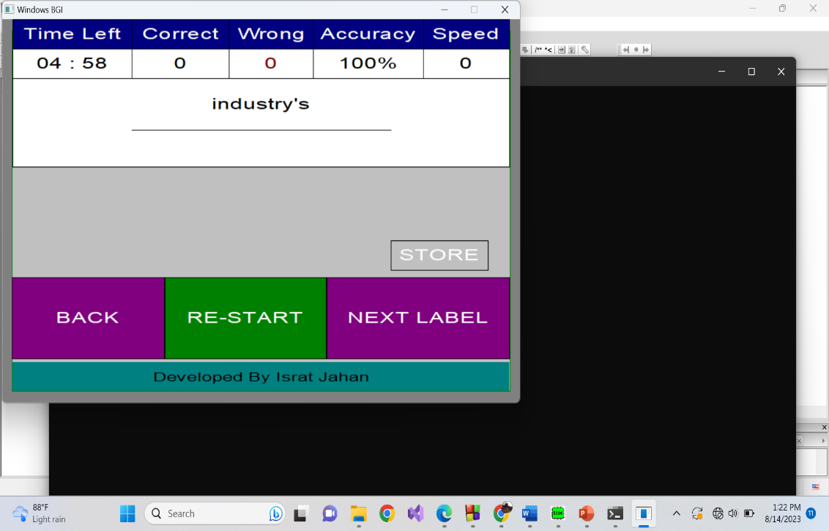  
*Figure 8. Typing Interface*

If time is over then a massage will be seen on screen which is “Time is Over”.

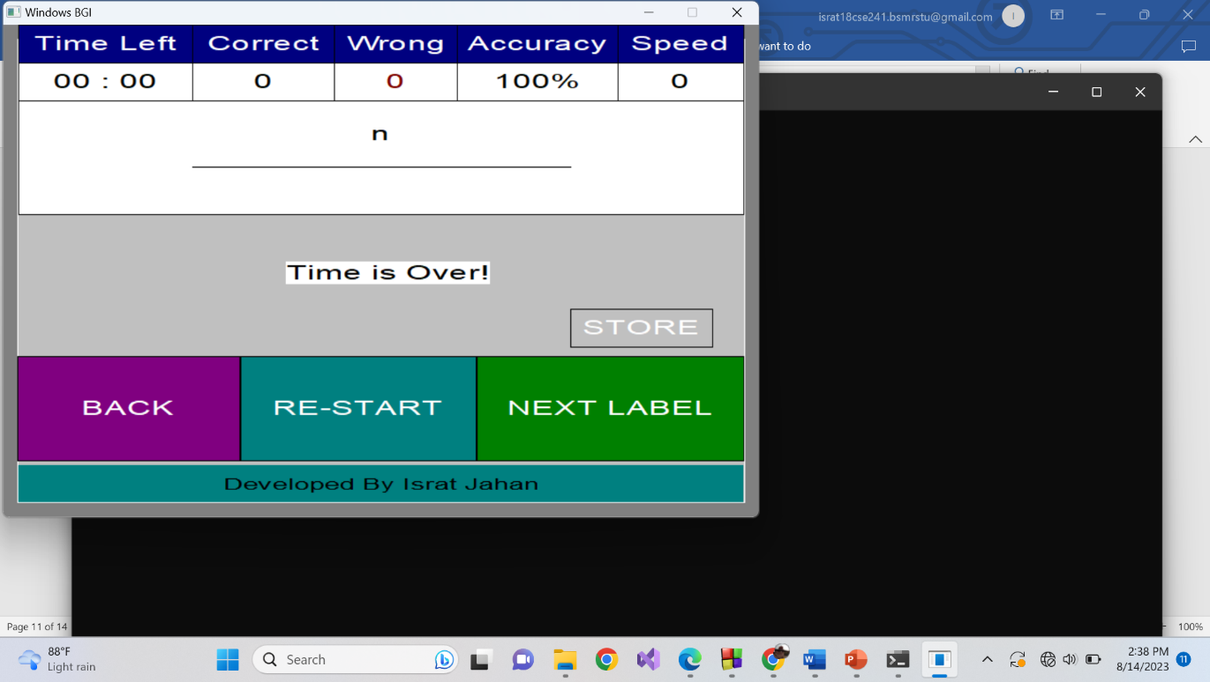

Figure 9. Time Over

**Exit:**

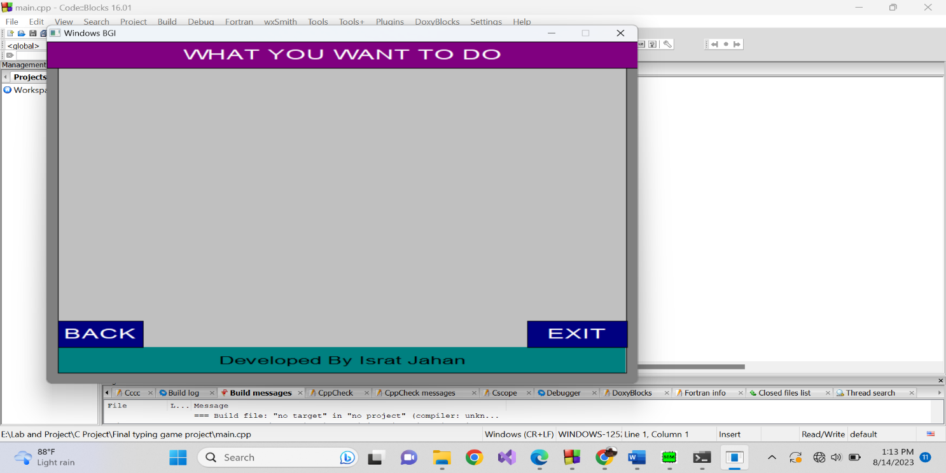

Figure 10. Exit

The window will be closed after clicking on EXIT.

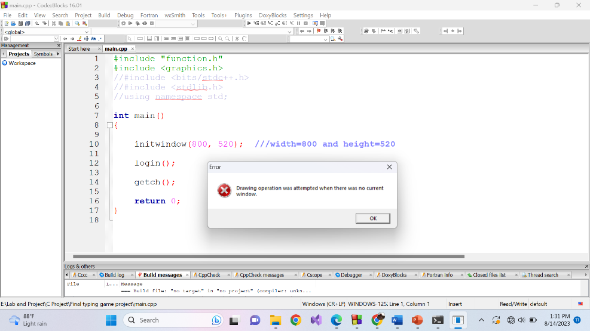

Figure 11. Close Window

# **Project’s goal:**

This typing speed game project will definitely improve the typing speed of its user. Easily any user can find his/her typing speed, accuracy. In future, the project will include sentence typing and also improve interface design.

# **References:**

<https://www.programiz.com/c-programming>

<https://www.learn-c.org/>

<https://www.geeksforgeeks.org/basics-file-handling-c/>

<https://www.studytonight.com/c/structures-in-c.php>